These notes are designed as a compliment to the CTechEd webinar and can serve as a reminder of the key ideas shared during the session. Space has been provided for you to add your own notes. You may find referring to your notes helpful when completing the optional follow-on assignment that is offered. If you were not present for the LIVE broadcast and are interested in in-service credit, you must complete both these notes and the follow-on and submit them to Sabrina.gates@cteched.com.
Unmapped Potential is a self-help book—a manifesto and a manual—designed to guide your thinking about your “map”. This is a mental map that guides your journey—professional and likely also personally. By becoming consciously aware of how your map has been created, making a commitment to challenge your own beliefs about yourself, and being courageous enough to review and revise your map, you can be the change that impacts your own success as well as the success of your students, colleagues and school.
Webinar Notes | Notes/Thoughts/Ponderings/Ideas
Session 1 Review  To get results you desire you must change your map. This begins by evaluating your map, followed by challenging your beliefs, leading to reimagining your map and then committing to action! | CHAT TIME: What idea from session 1 most resonates with you?
Re-imagining and Re-mapping—Navigating Change
BITTER OR BETTER? “You can’t be neutral on a moving train.”
--Howard Zinn, author, activist
This quote guides us to think about that as we travel through life, the landscape is always changing. You are always moving—foreword, backward—there is no standing still. Think about yourself as an educator, your work is ever-changing. New students, new schedules, new standards, new policies, new curriculums---and many other “news”. Changes are simultaneous and rapid! You may not be able to control all the changes nor the challenges they bring, but you can control YOUR response to changes. The difference between bitter and better is how you respond to that change. Change will elicit a response and your map plays a crucial role in the quality of that response.
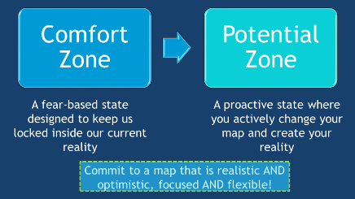  Comfort Zones are based on our current maps and reflect a commitment to maintaining what we know and can already do. This can result in missing out on something you are better suited for or an opportunity to have even greater impact.  The Potential Zone is where AWESOME happens. But to arrive here you must challenge your resistance to change and your fear of the unknown. You will also have to resist the bystanders who become fearful and uncomfortable simply watching you embrace change. | Chat Time: What can motivate you to move from Comfort Zone to Potential Zone?
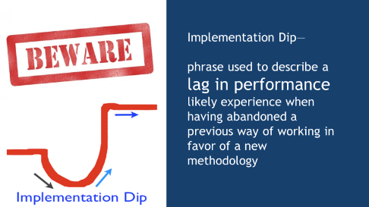
A danger in being able to move from your comfort zone to your potential zone is a fear of an Implementation Dip. This is the reason many people give up too early or decide too soon that new strategies are no good.

Most folks have a patterned, routine way of responding to change and unexpected challenges. Adversity strikes! Do you see this as temporary and context specific? OR is this pervasive and permanent? Your response largely determines how smoothly and quickly you will navigate the new landscape. Your way of responding likely fits with the half full or half empty analogy—optimist or pessimist.  Pessimism leads to despair and helplessness. People with a pessimistic view can easily find themselves caught in a cycle of giving up! Because they are discouraged, they begin to avoid difficult tasks which leads to negative consequences and the challenge-avoidance cycle is perpetuated all lead to being STUCK!  So, What Do You DO? Get a Better View!  - Have the courage to examine your PERSPECTIVE!  - Argue with your SELF-TALK.  - Embrace your ability to PRODUCTIVELY PROBLEM SOLVE. | Chat Time: Based on your responses to the survey questions, do you believe you are more pessimistic or optimistic? What impacts your view?
YOUR WORDS MATTER!
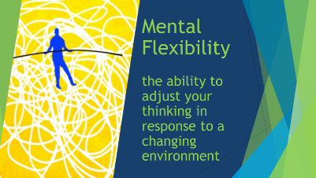
The words you use to frame a change or a challenging situation undoubtable impact the outcome. All of us likely have personal experiences where our words shaped what came next or someone else’s words altered our perception and reaction. The examples we just reviewed there is only one scenario, but vastly different outcomes based on what you tell yourself…
The words you use to describe your reality define your reality!
This very well may be the most useful tool in your toolbox! This allows for you to think about a problem in a new way, consider multiple perspectives and choose the best response. This takes you from limited options to endless solutions.
Can you increase your Mental Flexibility? YES!!! Learn something new, take a new route to school, have your students teach you something they know (and you don’t!). People usually think that growth happens after you learn something, coming from reflection about the experience—but powerful growth happens while you are learning something! Your brain is growing while you are learning something—this is neuroplasticity. The more novelty you feed your brain, the more flexible it will become.
ALTERNATIVE ROUTES  Taking an alternate route is not only an option to be entertained, but to be sought after. But alternate routes take confidence. People with confidence are comfortable with complexity and are willing to experiment. They are not afraid of the unknown because they can recall and relate past successes to new experiences. Ways to discover alternate routes are to talk with colleagues—in both similar and different scenarios to yours.  When you recognize a need for change and want to change on purpose with purpose, you focus. This does not equate to embracing every new everything that appears on your door step—have the courage to thoughtfully consider and commit and this includes saying NO in order to truly see an effort through by avoiding too many choices. Successful change efforts depend on your ability to act when you identify a need. You must first create a compelling why – a good rationale for the change. This applies to making changes in your school and to making changes in you map.  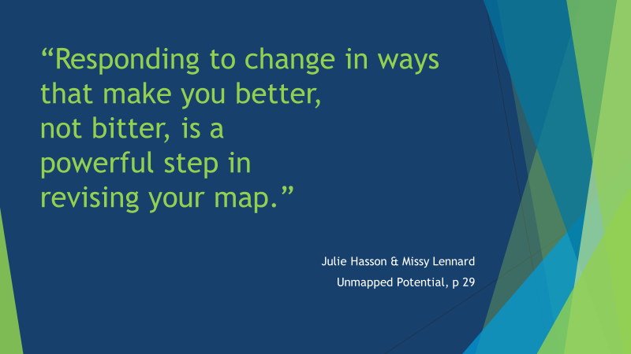 | Chat Time: Do you consider yourself a confident learner? Why or why not?

